Leetcode Problem 1. (Easy)

Minimum Depth of Binary Tree

Given a binary tree, find its minimum depth.

The minimum depth is the number of nodes along the shortest path from the root node down to the nearest leaf node.

**Note:** A leaf is a node with no children.

**Example 1:**

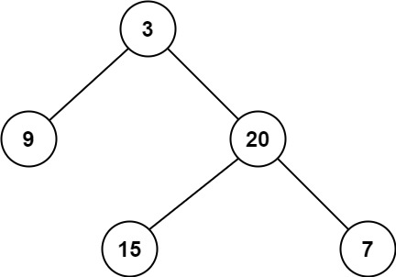

**Input:** root = [3,9,20,null,null,15,7]

**Output:** 2

**Example 2:**

**Input:** root = [2,null,3,null,4,null,5,null,6]

**Output:** 5

**Constraints:**

* The number of nodes in the tree is in the range [0, 105].
* -1000 <= Node.val <= 1000

Link: <https://leetcode.com/problems/minimum-depth-of-binary-tree/>

class Solution {

public int minDepth(TreeNode root) {

if (root == null) {

return 0;

}

if (root.left == null && root.right == null) {

return 1;

}

int minDepth = Integer.MAX_VALUE;

if (root.left != null) {

minDepth = Math.min(minDepth(root.left), minDepth);

}

if (root.right != null) {

minDepth = Math.min(minDepth(root.right), minDepth);

}

return minDepth + 1;

}

}

